# HOSPITAL MANAGEMNT SYSTEM IN DATA BASE MANAGEMENT SYSTEM

**18075A1228- G. VENKATESHWAR REDDY**

**18075A1229- G.SAI AMAL CHAITANYA**

**18075A1230- J.SAGAR**

**18075A1231- M.R.SWATHI**

**18075A1232- N.BHANU PRASAD**

**18075A1233- T.ASHWINI**

**18075A1234- SHIVA BHARGAV**

**INTRODUCTION**

This project is regarding Hospital Management system includes registration of patients, storing data their disease details into the system. It will also contain doctor’s information and will digitalize the whole billing system. My software has the facility to give a unique id for every patient and stores the details of every patient and staff automatically. It includes a search facility to know the current status of each room. User can search availability of a doctor and the details of a patient using the id.

The Hospital management System is developed to decrease the work that is done manually at Hospital centers. Every single step is done with the help of system, services such as employee registration, editing of different types such as employees, students into database, inquiries as well as complaints of customers. This Hospital management System will help in reducing lots of paper work and file work in these hospitals which will make easy management of hospital. It will also provide all the latest information to the management and hospital administration wherever theyask.

In this hospital management system, there are several categories such as:

1. Patientdetails
2. Roomsinformation
3. Information aboutdoctor
4. Billing
5. Medicines
6. Receptionist
7. Nurse

**HospitalManagement System:**

Medicines(entity)

MEDICINES

Employee(entity)

Employee

Patient(entity)

Patient

Doctor(entity)

Doctor

Nurse(entity)

nurse

Receptionist(entity)

receptionist

Records(entity)

Record

Rooms(entity)

Rooms

Medicines(entity)

Medicines

**E R DIAGRAM FOR HOSPITAL MANAGEMENT:**

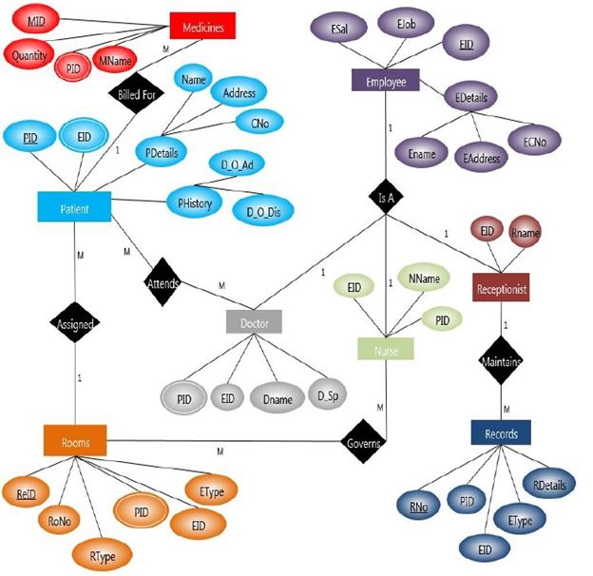

**CONCEPT DESIGN WITH E-R MODEL**:

**AIM**: Represent all the entities (Strong, Weak) in tabular fashion. Represent relationships in a tabular fashion. There are different ways of representing relationships as tables based on the cardinality. Represent attributes as columns in tables or as tables based on the requirement. Different types of attributes (Composite, Multi-valued, and Derived) have different way of representation.

The following are tabular representation of the above entities and relationships.

**Tables**

**Table1:Employee**

|  |  |  |  |
| --- | --- | --- | --- |
| Attribute | Description | Datatype | Condition |
| EID | Employee ID | Varchar2 | Primary key |
| Ename | Employee name | Varchar2 |  |
| EAddress | Employee address | Varchar2 |  |
| ECno | Contact number | number |  |
| Ejob | Job description | Varchar2 |  |
| Esal | Employee salary | number |  |

**Table:Patient**

|  |  |  |  |
| --- | --- | --- | --- |
| Attribute | description | Datatype | Condition |
| PID | Patient ID | Varchar2 | Primary key |
| EID | Employee ID | Varchar2 | Foreign key(ref-employee) |
| Name | Patient name | Varchar2 |  |
| Address | Patient address | Varchar2 |  |
| C no | Contact no | Number |  |
| D_O_Ad | Date of admission | Varchar2 |  |
| D_o_Dis | Date of discharge | Varchar2 |  |

**Table: Doctor**

|  |  |  |  |
| --- | --- | --- | --- |
| Attribute | Description | Datatype | Condition |
| EID | Employee ID | Varchar2 | Foreign key(ref-employee) |
| PID | Patient ID | Varchar2 | Foreign key(ref-patient) |
| D Name | Doctor’s name | Varchar2 |  |
| D_sp | Specialization | Varchar2 |  |

**Table: Nurse**

|  |  |  |  |
| --- | --- | --- | --- |
| Attribute | Description | Datatype | Condition |
| EID | Employee ID | Varchar2 | Foreign key(refemployee) |
| PID | Patient ID | Varchar2 | Foreign key(ref-patient) |
| N name | Nurse’s name | Varchar2 |  |

**Table: Receptionist**

|  |  |  |  |
| --- | --- | --- | --- |
| Attribute | Description | Datatype | Condition |
| EID | Employee ID | Varchar2 | Foreign key(refemployee) |
| R name | Receptionist’s name | Varchar2 |  |

**Table: Records**

|  |  |  |  |
| --- | --- | --- | --- |
| Attribute | Description | Datatype | Condition |
| R no | Record number | Varchar2 | Primary key |
| PID | Patient ID | Varchar2 | Foreign key(ref-patient) |
| EID | Employee ID | Varchar2 | Foreign key(refemployee) |
| E type | Employee type | Varchar2 |  |
| R details | Record details | Varchar2 |  |

**Table: Rooms**

|  |  |  |  |
| --- | --- | --- | --- |
| Attribute | Description | Datatype | Condition |
| Re ID | Room record ID | Varchar2 |  |
| R type | Room type | Varchar2 |  |
| Ro no | Room number | Varchar2 |  |
| PID | Patient ID | Varchar2 | Foreign key(ref-patient) |
| EID | Employee ID | Varchar2 | Foreign key(refemployee) |
| E type | Employee type | Varchar2 |  |

**Table: Medicines**

|  |  |  |  |
| --- | --- | --- | --- |
| Attribute | Description | Datatype | Condition |
| PID | Patient ID | Varchar2 | Foreign key(ref-patient) |
| MID | Medicine ID | Varchar2 | Primary key |
| Quantity | Quantity | Number |  |
| M name | Medicine name | Varchar2 |  |